2 PROJECT ORGANIZATION

This section specifies the process model for the project, describes the organizational structure of the project, identifies organizational boundaries and interfaces, and defines individual responsibilities for the different elements of the project.

2.1 PROCESS MODEL

The process used for this project will be a Waterfall Model such it is the most used model for small projects. In this model, each phase is executed completely before the beginning of the next phase and a feedback is taken after each phase to ensure that the project is on the right path. The different phases of the waterfall model are shown in Figure 2.1.

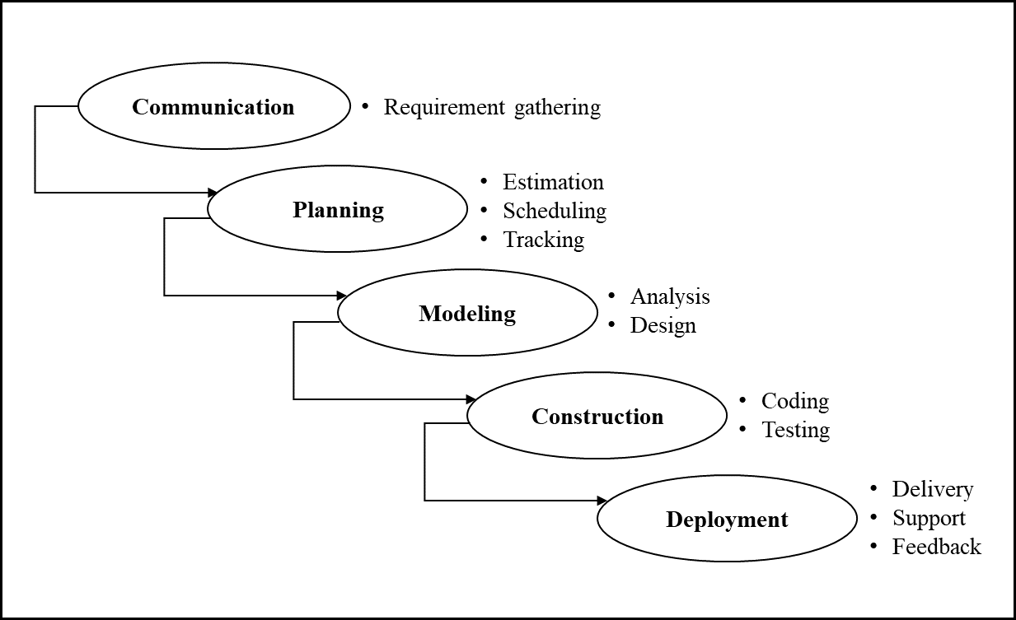

Figure 2.1 Waterfall Model

2.2 ORGANIZATIONAL STRUCTURE

StegSleuth’s Development Team is comprised of the following members:

* Emilio Acosta Ortiz
* Gabrielys Rivera Flores
* Kevin Medina Santiago
* Manuel Seda Batista
* Ricardo Vila Arturo

The Figure 2.2 shows the project development timeline.

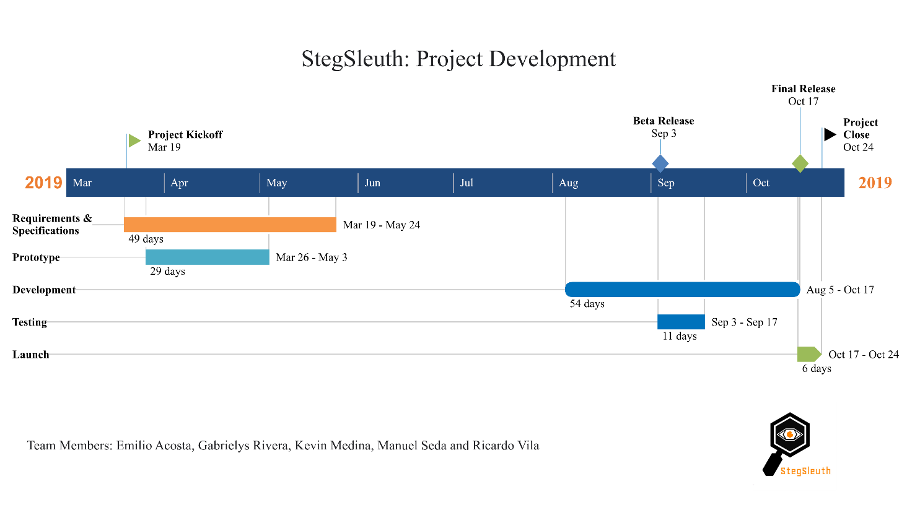

Figure 2.2 Project Development

2.3 ORGANIZATIONAL BOUNDARIES AND INTERFACES

Team members throughout the development of each phase will be responsible for coordinating meetings, updates, communications and equipment deliverables.

2.4 PROJECT RESPONSIBILITIES

To know each phase of the project, consult segment 2.2 of the document. The entire team is responsible for the entire development of the project and the successful delivery of the product. The tasks of team members can be delivered according to the experience and the phases below:

1. Requirements and Specifications
2. Prototype
3. Development
4. Testing
5. Launch

5.5 SCHEDULE

A detailed look of project milestones and due dates.

|  |  |  |  |
| --- | --- | --- | --- |
| Milestone | Start Date | Due Date | Notes |
| Prototype Development | March 26, 2019 | May 3, 2019 | Develop the prototype of the Graphical User Interface (GUI). |
| Desktop Application Development | August 5, 2019 | October 17, 2019 | Develop StegSleuth application for steganography and cryptography. |
| Testing Period I | September 3, 2019 | September 6, 2019 | Perform test to the developed application. |
| Application Readjustment Period I | September 6, 2019 | September 14, 2019 | Correct issues and bugs found on Test Period I. |
| Testing Period II | September 14, 2019 | September 17, 2019 | Perform test to the developed application. |
| Application Readjustment Period II | September 17, 2019 | October 17, 2019 | Correct issues and bugs found on Test Period II. |
| Desktop Application Launch |  | October 17, 2019 | Application goes online. |

Table 5.1 Software Development Milestones

https://www.tutorialride.com/software-testing/software-development-process-models.htm